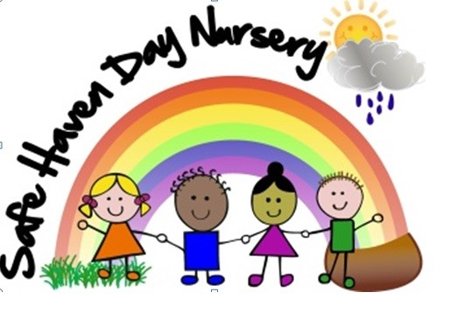 Safe Haven Day Nursery’s Holidays & Special Dates 2020 – These can be subject to change we
Will use nursery in a box for updates
Key Yellow Spring Term 11  Bright Green Summer Term 13  Red Autumn Term 14  Blue Funding Finished  Purple Nursery Closed  01 New Year’s Day Bank Holiday  06 Spring Term Starts  25 Chinese New Year week | JANUARY  S M T W Th F S  1 2 3 4  5 6 7 8 9 10 11  12 13 14 15 16 17 18  19 20 21 22 23 24 25  26 27 28 29 30 31 1 |  | JULY  S M T W Th F S  1 2 3 4  5 6 7 8 9 10 11  12 13 14 15 16 17 18  19 20 21 22 23 24 25  26 27 28 29 30 31 1 | 17 Graduation 2020  19 Summer Funding Finished
14 Valentine’s Day  17 Half Term week  24 Spring Term Back | FEBRUARY  S M T W Th F S  2 3 4 5 6 7 8  9 10 11 12 13 14 15  16 17 18 19 20 21 22  23 24 25 26 27 28 29 |  | AUGUST  S M T W Th F S  2 3 4 5 6 7 8  9 10 11 12 13 14 15  16 17 18 19 20 21 22  23 24 25 26 27 28 29  30 31 | 26 Summer Bank Holiay Closed
05 World Book day  09 -13 Sport Relief  14 Sikh New Year  22 Mothering Sunday  25 Pancake Day  30 No funded Week | MARCH  S M T W Th F S  1 2 3 4 5 6 7  8 9 10 11 12 13 14  15 16 17 18 19 20 21  22 23 24 25 26 27 28  29 30 31 |  | SEPTEMBER  S M T W Th F S  1 2 3 4 5  6 7 8 9 10 11 12  13 14 15 16 17 18 19  20 21 22 23 24 25 26  27 28 29 30 | 07 Autumn Funding starts  28 Harvest festival Singing at  The care homes  30 Nursery Photos
02 World Autism Day  06 Easter Holidays  09 Singing at care home  10 Good Friday Closed  13 Easter Holidays  13 Easter Monday Closed  20 Summer Term Starts  23 St George’s Day | APRIL  S M T W Th F S  1 2 3 4  5 6 7 8 9 10 11  12 13 14 15 16 17 18  19 20 21 22 23 24 25  26 27 28 29 30 1 2 |  | OCTOBER  S M T W Th F S  1 2 3  4 5 6 7 8 9 10  11 12 13 14 15 16 17  18 19 20 21 22 23 24  25 26 27 28 29 30 31 | 10 World Mental Health Day  19 Half Term  26 Half Term  30 Halloween
05 Peppa Pig Muddy Walk week  08 May Bank Holiday Closed  11 MPS Fundraising Week  25 Spring bank Holiday Closed  25 Half Term  30 20 Years 😊 | MAY  S M T W Th F S  3 4 5 6 7 8 9  10 11 12 13 14 15 16  17 18 18 20 21 22 23  24 25 26 27 28 29 30  31 |  | NOVEMBER  S M T W Th F S  1 2 3 4 5 6 7  8 9 10 11 12 13 14  15 16 17 18 19 20 21  22 23 24 25 26 27 28  29 30 | 02 Autumn Term Back  05 Bonfire Night  08 Remembrance Day  Children in Need  13 World Kindness Day  14 Diwali  20 Universal Children’s Day  26 Thanksgiving Day  30 Guru Nanak
08 Sports Day weeks  21 Father’s Day  22 Pre-School Parent Evening  23 Pre-School Parent Evening  23 Tiny Tots Parent Evening  24 Toddler Parent evening  25 Toddler Parent Evening | JUNE  S M T W Th F S  1 2 3 4 5 6  7 8 9 10 11 12 13  14 15 16 17 18 19 20  21 22 23 24 25 26 27  28 29 30 |  | DECEMBER  S M T W Th F S  1 2 3 4 5  6 7 8 9 10 11 12  13 14 15 16 17 18 19  20 21 22 23 24 25 26  27 28 29 30 31 | 07 Christmas Dinner  09 Christmas Dinner  11 Santa Visit  14 Party week  Christmas Jumper Day  18 Last Day of Funding  22 Nursery Closed  4th January Nursery Opens 2021
2019 Calendar Template © calendarlabs.com

